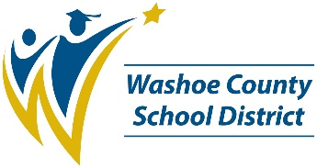**ROY GOMM ELEMENTARY**

*2023-2024 SCHOOL PERFORMANCE PLAN*

**Student Success Goal**

Increase student overall performance in both ELA and Math by 3% - 5% by the next SBAC assessment (2024).

To support students to achieve this goal, we will:

1. Determine resources that support effective implementation of tier 1 intervention strategies and instruction.
2. Weekly formative assessments (iReady), along with intentional feedback to identify areas of strength and potential growth.
3. Weekly goal setting meetings with scholars to set academic goals and assess progress.

**Student, Staff, and Family Partnerships Goal**

Communicate strategies to improve learning behaviors at home and at school.

To support students and families to achieve this goal, we will:

1. Establish a communication plan, via e-mail, mail, phone calls, Dojo, parent conferences, IC, weekly announcements, and website, to communicate academic status and interventions with families.
2. Use assessment data to include, iReady, SBAC, MAP (K-3), classroom and grade level formative and summative assessments to communicate with parents, their scholars academic progress.

**Resources for Parents and Families**

| **Quick Tips for Parents and Families** |  | **Resource Links** |
| --- | --- | --- |
| **Get involved!** Contact Barbara Barker for information about volunteering with our school. |  | **Infinite Campus Parent Portal**  *See your child’s grades, assignments, attendance information and important updates*  **www.washoeschools.net/ICparent** |
| **Stay connected!** Let the front office know if your phone number, email or home address has changed. |  | **Family Resource Centers**  *Basic needs assistance, resource referrals, and help with accessing services like SNAP*  **www.washoeschools.net/FRC** |
| **Know your child’s teachers!** We are here to support your child’s learning journey. |  | **Care Solace**  *Free and confidential help to access mental health care providers in your community*  **www.washoeschools.net/Care** |